Which is an accurate comparison?
What is trunk-based development?
While working with the five lean principles, what is the goal of using a pull-based system?
What is continuous integration?
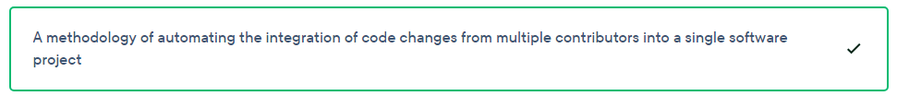
You are monitoring a DevOps release pipeline. Once you complete the acceptance testing phase for continuous delivery, what stage of the release pipeline would you monitor next?
How can enhancing observability improve the pace of innovation in your organization and create a sustainable environment for innovation?
When running a security audit of your application dependencies, what must you do to ensure the integrity of your entire software supply chain?
What is DevOps with respect to an organization's team structure?
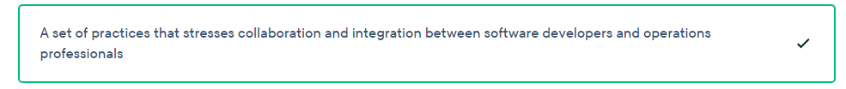
You released changes to your software through a DevOps deployment pipeline. You find security issues in the software in the production environment that were not present in the testing phases. What phase of DevOps should you improve to mitigate this in the future?
You have a complex application with backend and frontend that you release frequently and that uses feature branches. What is the most suitable way you can use to verify that the application is working correctly when you create pull requests and merge branches?
You're starting work on a new API that your client requested. The API must always work because the client's new system will be completely dependent on it for backend functionality. What kind of testing should you use to verify that the new API is communicating with the application?
You are developing a system with complex logic to determine settlements for stock trading. What type of test would be best to exercise a wide range of scenarios in determining payouts and the tax implications of a set of trades?
What is the purpose behind configuration management tools such as JetBrains TeamCity?
Your client requested detailed metrics on their system availability and they want their services to be observable. You provide the client with a dashboard that details the health of each of their services from your cloud provider. What is the client actually requesting?
Which sequence describes a typical test-driven development cycle?

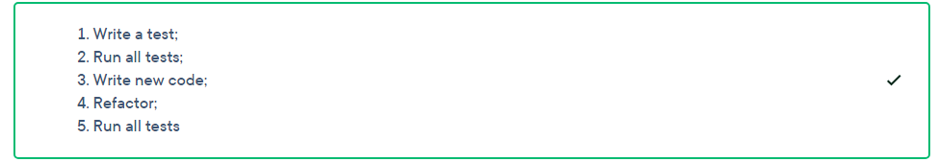

A large development team uses a trunk-based development system for a banking application. With so many developers checking in changes, code often comes in conflict and software builds are often broken. As a result, the senior developers must go back in and correct mistakes. How can this team prevent these problems?
What is the goal of artificial intelligence for IT operations (AIOps) in an organization?
How does observability improve the quality of software projects?

What is an indirect benefit of automation?
A business' owners hear that a key part of DevOps is handling failure. They are concerned about the focus on failure, which they want to avoid. How can you help them understand the importance of failure in the context of DevOps?
You inherited a project that does not use continuous integration/continuous delivery (CI/CD). In the current release process, developers create a feature branch from the main branch, make their changes, and merge that branch once it’s been approved. You want to introduce a shared coding standard between the team members. How can a CI/CD pipeline help you with this?
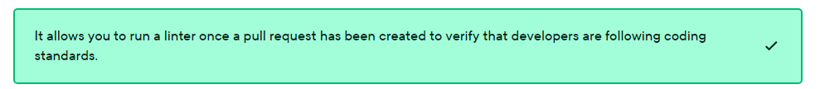
Your organization successfully eliminated unnecessary processes using the lean principles. There is still confusion throughout the organization's day-to-day operations, however. How can you improve these shortcomings?
Your company hired a new DevOps engineer manager who wants to automate all testing throughout the development process. Your first release doing this had more bugs than usual. How should your team proceed?
When applying software reliability engineering to a project, what is best to have in your project?

If you implement the test automation pyramid, which types of testing should you perform the least?
What does a deployment manifest contain?
What is a service-level indicator in the context of DevOps?
You must write a service-level agreement (SLA) for an API a partner business is providing. The API must provide 100% uptime over a period of 12 months because it is critical to your business functions. The business requires regular updates from the provider on how well it is meeting this target. Why would you use a service-level indicator in this scenario?

What is one reason to choose test-last development over test-driven development (TDD)?
Missing or out-of-date documentation frequently causes issues when deploying infrastructure. How does infrastructure from code help in this regard?
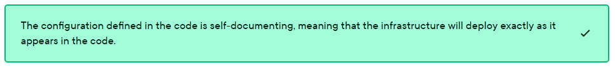

You are part of a small development team. You are deciding on how to manage your source control for an application. You must keep software development costs low and always have production-ready code for the next release. How should you proceed?
The quality assurance (QA) team found a bug while testing your new software. A new enhancement, which you no longer need in the release, caused the bug. How can you safely mitigate this issue in the most efficient manner?
Your systems experienced an hour of downtime because of a misconfigured server configuration file. You want to use artificial intelligence for IT operations (AIOps) to prevent this in the future. Why can't AIOps help in this scenario?

When releasing software to production, what should you always do to ensure application security when working in a team?
Your business uses the Gitflow model for your source control process. You are releasing features often, but some features are delayed because developers must manually fix small bugs that appear as they merge their code. How would switching to a trunk-based model resolve this?
More than 400 school districts of different sizes use your organization's application. The latest version of the app contains many large scale enhancements. You execute a basic deployment to all of your customers, but soon after you receive complaints from the largest school districts about issues with these new enhancements. How could you have avoided this issue affecting so many customers at once?
One team member releases updates to your system to production. When that team member is not available, pull requests cannot be approved and changes cannot be deployed, which causes large delays and anxiety before each sprint is completed. How would a DevOps transformation change the roles within your team and solve this problem?

How does observability make teams' time management more effective?
You must improve the speed at which new environments can be ready for code deployment. How could you use DevOps tools to accomplish this?
What is the main focus of automating the process of security checks when shifting left?
Generalizations that the human mind makes can be misleading and cause harm. Which is a valid, constructive generalization in the context of test-driven development (TDD)?
What type of testing involves deploying the entire environment in a production-like setting and having users rigorously test it using real-world scenarios?
An organization uses a traditional way of integrating new development changes into its software, which leads to a disconnect between the engineering team and the other teams. It also makes finishing projects more expensive. How can continuous integration (CI) help this organization?
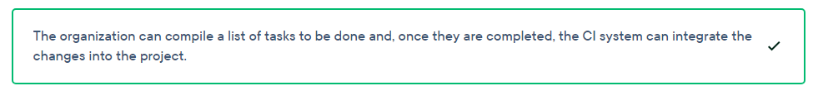
Which aspect of testing will likely have the greatest affect on decisions upper management makes?
During your company's transition to the continuous integration and continuous delivery (CI/CD) method, a high number of release versions were failing but only within some environments. What might explain this?

In a continuous integration/continuous delivery (CI/CD) environment, what is the first priority when a unit test fails?
You must develop a new set of features for a new project. You must calculate your error budget before releasing these features. How would you calculate this?
Your company, which has a product-focused mindset, completed a major project for a client. You focused a lot on customer collaboration during the process, while the client had a more traditional, project-oriented mindset. As a result, the project did not go well. How could you have followed a more project-focused mindset for this client?
A customer uses several message brokers to communicate between their microservices. This messaging system is not running correctly during deployments. Upon investigation, the developers found several edge cases where the system fails. How can you resolve this?
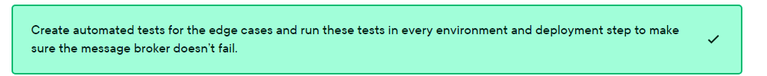
A large client of yours has three database servers, 10 application servers, and one cache server. The current deployment process requires you to take down all these servers as a precaution when you deploy a new update. How would automated infrastructure testing improve this?
You must test out a new set of virtual machines in production to see how customers react to some potential improvements. What kind of testing methodology would you follow?
You must upgrade the version of a framework you are using and you don't know how long it will take. What is the best approach?
When releasing software frequently to production, how can you maintain your application security?
You are a consultant for a new software project. You are trying to debug why it's running slower than usual. The issue is related to one of the microservices. How should you resolve this issue?
What does GitOps do?
During continuous deployment using a typical pipeline provider, you include some migration scripts that run against a target database. Once the build is complete, how can you view these scripts and their associated schema snapshots
You have a project mindset. What are you more inclined to focus on
You signed on to create an application for a new customer. The customer made it clear that they have a project focused mindset. How should you proceed with this application?
Your project team works on features in short cycles and releases them frequently. How would you automate this?
You are working on a financial application for your customer that requires strong security. How can you achieve this?
Which tool will detect a hardcoded password in source code

What is the purpose of using shift left on a system's security checks
Your team releases system updates frequently and you’re happy with the process. The product owner wants to start working more closely with the users to analyze what kind of changes they would want in the future, however. What could you add to your team to improve this?
What is an important requirement of source control in a continuous integration environment?
What is an advantage of applying value stream management toward identifying waste within your organization?
While performing a new build of your software on a Windows PC, some of the output does not look right. Your build log files are verbose so you should have an explanation. How can you check these log files
How can you host a cloud-native application

